**Table of Contents**

1 Scope 2

2 Definitions/Abbreviations 2

3 Architecture 2

3.1 Current State (CS) Architecture 2

3.2 Future State (FS) Architecture 2

4 Detailed Design 3

4.1 Finalized System Overview 4

4.2 User Interface Design 4

4.3 System Integration Detailed Design 12

4.4 System Performance 14

4.5 Reports Design 14

4.6 Database Design 17

4.7 Non-Database Management System Files 21

4.8 Software 22

4.9 Configuration Specification 40

5 References 41

6 Final Design Specification Approvals 41

This Design Specification (DS) describes the overall solution for ESRA, its components, and intended users. It describes how the system is installed and configured to meet functional requirements.

# Scope

This document defines the DS for the ESRA application

# Definitions/Abbreviations

Reference ITD-0289: Lexicon of Computer Terminology for a complete list of definitions. Also, reference Design Specification guidance for general definitions pertaining to DS.

For project specific definitions used for this document, reference the following table:

| **Term** | **Definition** |
| --- | --- |
| ESRA |  |
|  |  |

# Architecture

## Current State (CS) Architecture

### Overview and Shortcomings of the CS

Reference (if any) to the legacy design document

### CS Logical Architecture Diagram

Reference (if any) to the legacy Architecture diagram

## Future State (FS) Architecture

### FS Business Architecture Diagram

#### Application Overview

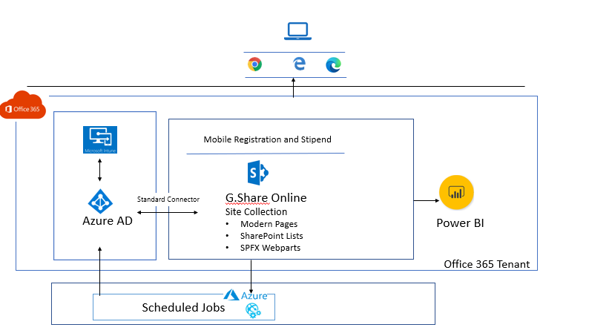

**Core Platform**: G.Share Online on SharePoint online

**Application Components**: Custom Webparts using SPFx framework.

**Backend**: SharePoint Lists and Libraries

**Scheduled Jobs**: Azure WebJobs

**Reports**: PowerBi and Excel

**Authentication and Integration**: Azure AD

**Hosting Details:**

|  |  |  |  |
| --- | --- | --- | --- |
| **Environment** | **G.Share Online** | **PowerBi** | **Azure** |
| Dev |  |  |  |
| Staging |  |  |  |
| Production |  |  |  |

# Detailed Design

## Finalized System Overview

## User Interface Design

### Mock-Ups

#### Beneficiary Module

| **DS ID** | **Description** | **Screen Shot** |
| --- | --- | --- |
|  | Enrollment Screen |  |
|  | Terms & Conditions |  |
|  | Request Enrollment |  |
|  | Submitted Request |  |
|  | Request History |  |
|  | Update Request |  |
|  | Cancel Request |  |
|  | Request on behalf of |  |

#### Manager/Reviewer Module

| **DS ID** | **Description** | **Screen Shot** |
| --- | --- | --- |
|  | Pending Request |  |
|  | Completed Request |  |

#### Power user Module

| **DS ID** | **Description** | **Screen Shot** |
| --- | --- | --- |
|  | Reports Screen |  |
|  | Payroll Report |  |
|  | Settings Screen |  |
|  | Manage Power User |  |
|  | Pending Requests |  |
|  | Manage Requests |  |
|  | Request History |  |
|  | Cancel Request |  |
|  | Request on behalf of |  |

### Information Security and Compliance

| **DS ID** | **Use role** | **Frontend Permission** | **Backend Permission** |
| --- | --- | --- | --- |
|  | Beneficiary | Enrollment Screen and Approve and Reject Screen | Contribute without Delete permission |
|  | Manager | Enrollment Screen and Approve and Reject Screen | Contribute without Delete permission |
|  | Reviewer | Enrollment Screen and Approve Reject Screen | Contribute without Delete permission |
|  | Power user | Enrollment Screen, Approve and Reject Screen, Reports and Settings Screen | Full Control |
|  | System Admin | Enrollment Screen, Approve and Reject Screen, Reports and Settings Screen | Site Collection Admin |

## System Integration Detailed Design

### Beneficiary Module

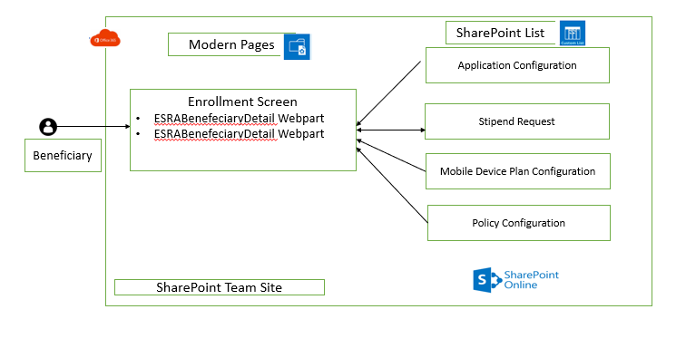

### Reviewer/Manager Module

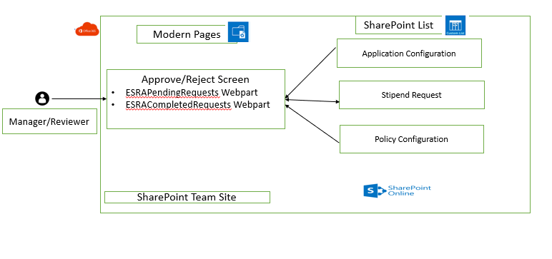

### Power User Module

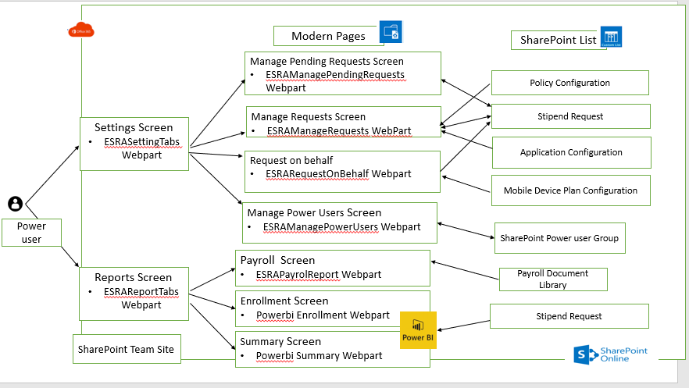

### Azure Web Jobs

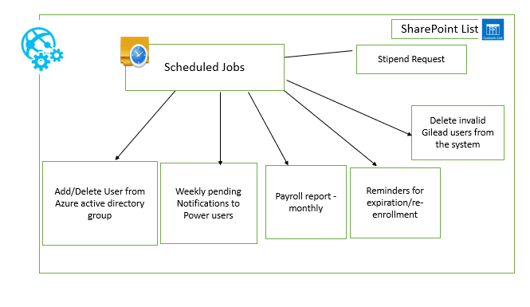

## System Performance

Performance related requirements would be inherited from G.Share online platform

## Reports Design

### Solution Name: ESRAPayrollReport

Webpart Name: ESRAPayrollReport

| **DS ID** | **Event** | **Description** |
| --- | --- | --- |
|  | **OnLoad** | Load webpart content as   * Country:   List Name: Countries  Value: Title column |
|  | **OnLoad** | Download Button text should be displayed with:   * + **List name**: Application Configuration   + **Filter condition**: Key = Download button and country = current user country (default US)   + **Button text:** Value column |
|  | **Webpart Actions Download** | Get the file from following Location:   * 1. **Document Library name**: Payroll Reports   2. **Filter condition**: Folder = Country Selected and Year = year Selected and Month =Month Selected |
|  | **Webpart Actions Download** | User should be able to download the file |

### Powerbi Enrollment Report Webpart

| **DS ID** | **Event** | **Description** |
| --- | --- | --- |
|  | **OnLoad** | Load grid data with following:   * 1. **List name**: Stipend Request   2. **Column to be shown in Grid**: Beneficiary, Requestor, Department, Requested Date, Reviewer, Date Reviewed, Status, Policy Number |
|  | **OnLoad** | **Filter Options:** Beneficiary, Requestor, Department, Requested Date, Reviewer, Reviewed Date, Status |
|  | **Filter** | User can filter the grid by selecting any filter condition provided to get the refined data to be displayed. |

### Powerbi Summary Report Webpart

| **DS ID** | **Event** | **Description** |
| --- | --- | --- |
|  | **OnLoad** | User will be provided with Search box to select the user.  Enrolled Date range |
|  | **OnLoad** | Grid will be displayed.  **Column to be shown in Grid**: Reviewer, Enrolled Date, Stipend Amount |
|  | **Search** | Based on the user selected in the search box and date range selected, grid will display all the direct reportee of the user with their stipend amount from Stipend Request list and roll up stipend amount of the reportee |

## Database Design

SharePoint lists will be maintained as backend to store the data and configuration related data of the application.

### Lists Schema

#### Countries

|  |  |  |
| --- | --- | --- |
| **DS ID** | **Column Name** | **Data Type** |
|  | Title | Single line of text |

#### Application Configuration

|  |  |  |  |
| --- | --- | --- | --- |
| **DS ID** | **Column Name** | **Data Type** | **Choice Options/Look up Details** |
|  | Key | Single line of text |  |
|  | Value | Multiline of text |  |
|  | Config Type | Single line of text |  |
|  | Country | Lookup | Look up from Countries list Title Column |
|  | Links | Single line of text |  |
|  | Image URL | Single line of text |  |
|  | Role | Multiselect | FTE  Contractor |

#### Policy Configuration

|  |  |  |  |
| --- | --- | --- | --- |
| **DS ID** | **Column Name** | **Data Type** | **Choice Options/Look up Details** |
|  | Policy Document Url | Hyperlink |  |
|  | Active | yes/no |  |
|  | Country | Lookup | Look up from Countries list Title Column |
|  | Policy Type | Choice | Enrollment  Cancel |
|  | Role | Multi select | FTE  Contractor |

#### Mobile Device Plan Configuration List

|  |  |  |  |
| --- | --- | --- | --- |
| **DS ID** | **Column Name** | **Data Type** | **Choice Options/Look up Details** |
|  | Stipend Category | Choice | Basic  Standard  High |
|  | Stipend Description | Multiline of Text |  |
|  | Monthly Amount | Single line of text |  |
|  | Country | Lookup | Look up from Countries list Title Column |
|  | Active | yes/no |  |

#### Stipend Request

|  |  |  |  |
| --- | --- | --- | --- |
| **DS ID** | **Column Name** | **Data Type** | **Choice Options/Look up Details** |
|  | Beneficiary | Person |  |
|  | Beneficiary Type | Choice | Fulltime  Contractor |
|  | Beneficiary Job Grade | Single line of Text |  |
|  | Beneficiary Department | Single line of Text |  |
|  | Beneficiary Home Country | lookup | Look up from Countries list Title Column |
|  | Beneficiary Current Country | lookup | Look up from Countries list Title Column |
|  | Stipend Category | Single line of Text |  |
|  | Stipend Amount | Number |  |
|  | Agreement Accepted | yes/no |  |
|  | Request Date | Date & Time |  |
|  | Request Type | Choice | Enroll  Update  Cancel |
|  | Requester | Person |  |
|  | Status | Choice | In-Progress  Approved  Rejected  Cancelled  Pre-Approved  Auto-Approved |
|  | Is Active | yes/no |  |
|  | Approval Reject Date | Date & Time |  |
|  | Manager | Person |  |
|  | Policy Document Url | Person |  |
|  | Policy Name | Single line of Text |  |
|  | Comments | Multiline of Text |  |

#### Email Templates

|  |  |  |
| --- | --- | --- |
| **DS ID** | **Column Name** | **Data Type** |
|  | Email Subject | Single line of text |
|  | Email Body | Multiline of Text |
|  | Notification Type | Single line of text |
|  | CC | Single line of text |
|  | To | Single line of text |
|  | Template Name | Single line of text |

#### Payroll Reports Document Library

|  |  |  |
| --- | --- | --- |
| **DS ID** | **Column Name** | **Data Type** |
|  | Country | Folder |
|  | Month | Single line of text |
|  | Year | Single line of text |

## Non-Database Management System Files

Define the design of all non-DBMS files, including details of the usage of each file; if the file is used for input, output, or both; if the file is a temporary file; an indication of which modules read and write the file, etc.; and file structures (refer to the data dictionary).The file structure information should:

* Identify record structures, record keys or indexes, and reference data elements within the records.
* Define record length (fixed or maximum variable length) and blocking factors. Define file access method, for example, index sequential, virtual sequential, random access, etc.
* Estimate the file size or volume of data within the file, including overhead resulting from file access methods.
* Define the update frequency of the file; if the file is part of an online transaction-based system, provide the estimated number of transactions per unit time, and the statistical mean, mode, and distribution of those transactions.

| **DS ID** | **Description** |
| --- | --- |
|  | Pay roll report excel will have the following columns:   1. Co Code 2. Batch ID 3. File # 4. Earnings 4 Code 5. Earnings 4 Amount 6. Pay # 7. Tax Frequency |
|  | Within the excel report there can be multiple sheets present and payroll records will present defined by the following logic:  Users having Legal_Entity = '001' and HREmployeeNumber in (151568,152405,201538,205786) THEN Sheet Name is 'QWM'  WHEN Legal_Entity = '001' THEN Sheet Name is 'QWK'  WHEN Legal_Entity = '006' THEN Sheet Name is 'TQU'  WHEN Legal_Entity = '007' THEN Sheet Name is 'UNX' |
|  | For all the records “Co Code” field will be populated using the following logic  Users having Legal_Entity = '001' and HREmployeeNumber in (151568,152405,201538,205786) THEN Sheet Name is 'QWM'  WHEN Legal_Entity = '001' THEN Co Code is 'QWK'  WHEN Legal_Entity = '006' THEN Co Code is 'TQU'  WHEN Legal_Entity = '007' THEN Co Code is 'UNX' |
|  | For all records “Batch ID” column will have the value “Stipend” |
|  | For all records “Earnings 4 Code” column will have the value “CEL” |
|  | For all records “Tax Frequency” column will have the value “B” |
|  | For all records “Pay#” column will have the value “1” |
|  | For rest of the records population refer section |

## Software

### Global Navigation

Solution Name: ESRATopNavigation

Webpart Name: ESRATopNavigation

| **DS ID** | **Event** | **Description** |
| --- | --- | --- |
|  | **Source** | Global Navigation |
|  | **OnLoad** | Check if User location is from Allowed countries from Application configuration list.  If No message will be displayed  Please note that this is only for US employees. Employee Stipend request application is not yet live in your country. Please raise a SPARC if you have any queries. |
|  | **OnLoad** | Check if user FTE/Contractor: check if user is FTE/Contractor based user profile property.  **If FTE and Power User**  use site navigation to Show following.  Overview | Enroll | Approve/Reject | Reports | Settings |
|  | **OnLoad** | **If Contractor and Power User**  use site navigation to Show following.  Overview | Enroll | Reports | Settings |
|  | **OnLoad** | **If FTE**  use site navigation to Show following.  Overview | Enroll | Approve/Reject |
|  | **OnLoad** | **If Contractor**  use site navigation to Show following.  Overview | Enroll |

### Stipend Enrollment Screen

#### Solution Name: ESRAEnrollement

Webpart Name: ESRABenefeciaryWelcomeDetail

| **DS ID** | **Event** | **Description** |
| --- | --- | --- |
|  | **Source** | Application Configuration list |
|  | **OnLoad** | Display the current user display name. |
|  | **OnLoad** | Based on the current user “country” and User type i.e., FTE/Contractor system will pull content from application configuration list to be displayed  **Application Configuration list**  **Fields**  Key: “BasicStipendInfo”  Value: Value Column  Country: Current user country (Default US)  Role: FTE/Contractor |

#### Solution Name: ESRAEnrolledAddUpdateStipendDetail

Webpart Name: ESRABenefeciaryDetail

| **DS ID** | **Event** | **Description** |
| --- | --- | --- |
|  | **Source** | Stipend Request, Mobile Device Plan Configuration, Policy Configuration, Email Templates |
|  | **onLoad** | If there are no pending/approved request for the current user in the Stipend Request list, then system will check if the current user is Full time /contractor employee.  getting current **User profile** information. |
|  | **onLoad** | If the user is Full time employee, Grid will be displayed with the stipend information pulled from Mobile Device Plan Configuration list based on the current user country and link to Terms & condition will be displayed.  **Mobile Device Plan Configuration** **list**  **Fields**  Stipend Category  Stipend Description  Stipend Amount |
|  | **OnLoad** | If the user is Contractor, link to Terms & condition will be displayed.  Terms & condition will be displayed based on the current user country, active, Role and Policy Type |
|  | **OnLoad** | Check if there are active Pending/Approved request for the current user in Stipend Request list  **Stipend Request List:** Filter list based on the Beneficiary=” current user” & Status=” In-Progress/Auto-Approved/Approved “& IsActive=” true” |
|  | **OnLoad** | If there is any then the stipend request information will be displayed with option to Cancel/Update  **Stipend Request List:**  Beneficiary  Manager  Stipend Amount  Request Status  Request Date &Time |
|  | **OnLoad** | **Request History**  Show the version history data for selected beneficiary.   * 1. List name: Stipend Request   2. Filter condition: Item = Clicked item in grid and if item current version have status as “In progress” hide this version   3. **Column to be shown in Grid:** Requestor ,Requestor Type, Date requested, Status Reviewer, Date Approved /rejected , Policy umber ,Category , Monthly Stipend ,Comments |
|  | **Ok Click** | Close the version history popup |
|  | **Form Submit Controls** | **Terms & Condition link**  If user is Full time employee must Select on the Stipend category from the grid and click on the link “T & C link” and pop up will appear with the terms and condition which user must agree before enrolling for stipend |
|  | **Form Submit Controls** | Link to Terms & condition will be displayed based on the current user country, active status, Role ,Policy Type.  **Policy Configuration list**  **Fields**  PolicyDocumentUrl  Country  Role  Policy Type |
|  | **Form Submit Controls** | If user is contractor click on the link “Click here to Agree Gilead Stipend terms and condition” and pop up will appear with the terms and condition which user must agree before enrolling for stipend |
|  | **Form Submit Controls** | Link to Terms & condition will be displayed based on the current user country, active, Role ,Policy Type.  **Policy Configuration list**  **Fields**  PolicyDocumentUrl  Country  Role  Policy Type |
|  | **Request Enrollment Submit** | **Validation check:**  System will check if the user has selected one of the stipend categories and agreed to Terms & condition if not a Request Enrollment button will be disabled. |
|  | **Request Enrollment Submit** | **Stipend Enrollment**  Once user click on Request enrollment the system will store all the user related data,  **Stipend Request list**  **Fields**   |  | | --- | | Beneficiary =Current user | | Beneficiary Type=fulltime/contractor | | Beneficiary Job Grade=Current user profile | | Beneficiary Department= Current user profile | | Beneficiary Home Country= Current user profile | | Beneficiary Current Country= Current user profile | | Stipend Category=user selection | | Stipend Amount= user selection | | Agreement Accepted= user selection | | Request Date=Current Date | | Request Type=Enrollment | | IsActive=yes  Status=In progress | | Reviewer=Current User manager based on User profile property | | Manager= Current User manager based on User profile property | | PolicyDocumentUrl=based on current user country-based policy | |
|  | **Request Enrollment Submit** | Grid will be displayed with stipend pending request details that user has selected.  **Stipend Request List**  **Fields**  Beneficiary  Manager  Stipend Amount  Request Status  Request Date &Time |
|  | **Request Enrollment Submit** | Sending notification  If (Status=Auto-Approved)  Filter: Notification Type= ‘Auto-Approved’  **Email Templates:**  **Fields:**  Email Subject  Email Body  TO  CC |
|  | **Request Enrollment Submit** | Sending notification  If (Status=In-Progress)  Filter: Notification Type= ‘NewRequest’ and ‘NewRequestToReviewer’  **Email Templates:**  **Fields:**  Email Subject  Email Body  TO  CC |
|  | **Update Request** | On clicking the update request the user will be provided with stipend information grid to change the stipend category and must agree to the terms and condition before enrolling for the new stipend.  **Mobile Device Plan Configuration** **list**  **Fields**  Stipend Category  Stipend Description  Stipend Amount |
|  |  | System will update record in the stipend Request list with the new selected category and Terms and condition and send notification to the Manager.  **Stipend Request list**  **Fields**   |  | | --- | | Stipend Category=User selection | | Stipend Amount=User Selection | | Request Date=Current date | | Request Type=Update | | Status=In progress | | PolicyDocumentUrl= based on current user country based policy | |
|  | **Cancel Request** | On clicking the Cancel request a pop up appears with a message about request being cancelled. |
|  | **Cancel Request** | System will update status of the record and make the request inactive.  **Stipend Request list**  **Fields**   |  | | --- | | Request Date=Current Date | | IsActive=No | | Status=Cancelled | | Comments=user input | |
|  | **Cancel Request** | User will be displayed the stipend information grid if you are the full-time employee and Terms and condition link.  **Mobile Device Plan Configuration** **list**  **Fields**  Stipend Category  Stipend Description  Stipend Amount |

### Approve/Reject Screen

#### Solution Name: ESRAPendingRequest

Webpart Name: ESRAPendingRequests

| **DS ID** | | **Description** | | |
| --- | --- | --- | --- | --- |
|  | | **Source** | Stipend Request, Application Configuration, Email Templates | |
|  | | **OnLoad** | 1. Load grid data with following:  * **List name**: Stipend Request * **Filter condition**: Status = In progress and Request type = Enrolled and Reviewer = Current user * **Column to be shown in Grid**: Beneficiary, Stipend Type, Request Date, Beneficiary Department | |
|  | | **Approve Click** | Validation**:**  At least 1 request should be selected.  if not: print validation message | |
|  | | **Approve Click** | Check for the maximum request selection.  if not: print validation msg | |
|  | | **Approve Click** | Open a popup for comments: | |
|  | | **Close on Modal Popup** | Close the popup. | |
|  | | **Submit click on Modal Popup** | | Update the Selected items in Stipend list with:   * Status to Approved. * Approval Reject Date to today date. * Comments to User comments * Send mail to Beneficiary. * Close the popup. * Rebind the grid. |
|  | | **Reject Click** | | Validation**:**  At least 1 request should be selected.  if not: print validation message |
|  | | **Reject Click** | | Check for the maximum request selection.  if not: print validation msg |
|  | | **Reject Click** | | Open a popup for comments |
|  | | **Close on Modal Popup** | | Close the popup |
|  | | **Submit click on Modal Popup** | | Update the Selected items in Stipend list with   * Status to Reject. * Approval Reject Date to today date. * Comments to User comments * Send mail to Beneficiary. * Close the popup. * Rebind the grid |

#### Solution Name: ESRACompletedRequests

Webpart Name: ESRACompletedRequests

| **DS ID** | **Event** | **Description** |
| --- | --- | --- |
|  | **Source** | Stipend Request, Application Configuration |
|  | **OnLoad** | 1. Load grid data with following:  * **List name**: Stipend Request * **Filter condition**: Status! = In progress and Request type = Enrolled and Reviewer = Current user * **Column to be shown in Grid:** Column to be shown in Grid: Beneficiary, Stipend Type, date Approved /Rejected Status, Department History |
|  | **Webpart Actions - Export to Excel** | Export the grid data in excel format with following columns: Beneficiary, Stipend Type, date Approved /Rejected Status, Department |
|  | **Click -Request Version History** | 1. Show the version history data for selected beneficiary.  * List name: Stipend Request * Filter condition: Item = Clicked item in grid and if item current version have status as “In progress” hide this version * Column to be shown in Grid: Requestor, Requestor Type, Date requested, Status Reviewer, Date Approved /rejected, Policy umber ,Category , Monthly Stipend ,Comments |
|  | **Ok Click -Request Version History** | Close the version history popup |

### Reports Screen

#### Solution Name: ESRAReports

Webpart Name: ESRAReportTabs

| **DS ID** | **Event** | **Description** |
| --- | --- | --- |
|  | **Source** | Application Configuration |
|  | **OnLoad** | Load data with following:   * **List name**: Application Configuration * **Filter condition**: Key = Reports Tab and country = current user country |
|  | **OnLoad** | **Create tabs with:**   * 1. Tab Name: value field   2. Navigation Link: url field   3. Background / tab Image: image URL |
|  | **Webpart Actions**  Click on tabs | Navigate to the link url |

#### Solution Name: ESRAPayrolReport

Webpart Name; ESRAPayrolReport

| **DS ID** | **Event** | **Description** |
| --- | --- | --- |
|  | **Source** | Application Configuration, Payroll Reports |
|  | **OnLoad** | Load webpart content as  Country:  **List Name**: Countries  **Value**: Title column |
|  | **Webpart Actions Download** | Get the file from following Location:   1. **Document Library name**: Payroll Reports 2. **Filter condition**: Folder = Country Selected and Year = year Selected and Month =Month Selected |
|  | **Webpart Actions Download** | User should be able to download the file |

### Settings Screen

Solution Name: ESRASettings

Webpart Name: ESRASettingTabs

| **DS ID** | **Event** | **Description** |
| --- | --- | --- |
|  | **Source** | Application Configuration |
|  | **OnLoad** | Load webpart content with following details:   * **List name**: Application Configuration * **Filter condition**: Key = Settings Tab and country = current user country |
|  | **OnLoad** | **Create tabs with:**   * Tab Name: value field * Navigation Link: url field * Background / tab Image: image URL |
|  | **Webpart Actions - Click on tabs** | Navigate to the link url |

### Manage Power Users Screen

Solution Name: ESRAManagePowerUsers

Webpart Name: ESRAManagePowerUsers

| **DS ID** | **Event** | **Description** |
| --- | --- | --- |
|  | **Source** | Stipend Request, Application Configuration |
|  | **OnLoad** | Load webpart content with following details:   * **Group name**: Power User group * **Column to be shown in Grid**: Email and Display Name |
|  | **Webpart Actions**  **Add click** | Validation**:**  validate people picker with empty value if yes show validation message |
|  | **Add click** | check if user is already existing in the group. |
|  | **Add click** | if yes show message user already exists |
|  | **Add click** | Add user in the Group.  Re-bind the grid. |
|  | **Delete Click** | Validation**:**  Confirm: "Are you sure to delete the user" |
|  | **Delete Click** | Close: Close the confirmation box |
|  | **Delete Click** | Delete the user from group.  Rebind the grid |

### Manage Pending Requests Screen

Solution Name: ESRAManagePendingRequests

Webpart Name: ESRAManagePendingRequests

| **DS ID** | **Event** | **Description** |
| --- | --- | --- |
|  | **Source** | Stipend Request, Application Configuration, Email Templates |
|  | **OnLoad** | Load grid data with following:   * 1. **List name**: Stipend Request   2. **Filter condition**: Status = In progress and Request type = Enrolled   3. **Column to be shown in Grid**: Beneficiary, Stipend Type, Request Date, Reviewer |
|  | **Webpart Actions**  **Approve Click** | Validation**:**  At least 1 request should be selected.  if not: print validation message |
|  | **Approve Click** | Check for the maximum request’s selection.  if not: print validation msg |
|  | **Approve Click** | Open a popup for comments |
|  | **Close click on popup** | Close the popup. |
|  | **Submit click on popup.** | Update the Selected items in Stipend list with   * Status to Approved. * Approval Reject Date to today date. * Comments to User comments * Send mail to Beneficiary. * Close the popup. * Rebind the grid. |
|  | **Reject Click** | Validation**:**  At least 1 request should be selected.  if not: print validation message |
|  | **Reject Click** | Check for the maximum request’s selection.  if not: print validation msg |
|  | **Reject Click** | Open a popup for comments: |
|  | **Close click on popup** | Close the popup. |
|  | **Submit click on popup** | Update the Selected items in Stipend list with   * Status to **Rejected**. * Approval Reject Date to today date. * Comments to User comments * Send mail to Beneficiary. * Close the popup. |
|  | **Submit click on popup** | Rebind the grid. |
|  | **Export to Excel** | Export the grid data in excel format with following columns: Beneficiary, Stipend Type, Date Requested , Reviewer |

### Manage Requests Screen

Solution Name: ESRAManageRequests

Webpart Name: ESRAManageRequests

| **DS ID** | **Event** | **Description** |
| --- | --- | --- |
|  | **Source** | Application Configuration, Stipend Request |
|  | **OnLoad** | Load grid data with following:   * 1. **List name**: Stipend Request   2. **Filter condition**: Status = Approved or Auto Approved and Request type = Enrolled   3. **Column to be shown in Grid**: Beneficiary, Approval Reject Date, Policy Number |
|  | **Webpart Actions**  **Opt-Out/Cancel Click** | Open a popup for comments |
|  | **Close click on the popup** | Close the popup. |
|  | **Ok click on the popup** | Update the Selected items in Stipend list with   * Status to Cancelled. * Approval Reject Date to today date. * Comments to User comments * Send mail to Beneficiary. * Close the popup. * Rebind the grid. |
|  | **Click Request Version History** | Show the version history data for selected beneficiary.   1. **List name:** Stipend Request 2. **Filter condition:** Item = Clicked item in grid and if item current version have status as “In progress” hide this version 3. **Column to be shown in Grid:** Requestor, Requestor Type, Date requested, Status Reviewer, Date Approved /rejected, Policy umber ,Category , Monthly Stipend ,Comments |
|  | **Ok Click on Request Version History** | Close the version history popup. |
|  | **Search Click** | Check if search string is not empty. |
|  | **Search Click** | Filter grid data based on Following columns:   1. Beneficiary, Date approved, Policy number. |

### RequestOnBehalf Screen

Solution Name: ESRARequestOnBehalf Solution

Webpart Name: ESRARequestOnBehalf Webpart

| **DS ID** | **Event** | **Description** |
| --- | --- | --- |
|  | **Source** | Stipend Request, Mobile Device Plan Configuration, Email Templates |
|  | **OnLoad** | Power user will be provided with People picker control to select a beneficiary for stipend request. |
|  | **OnLoad** | Grid will be displayed with the stipend information pulled from Mobile Device Plan Configuration list based on the selected beneficiary country.  **Mobile Device Plan Configuration list**  **Fields**  Stipend Category  Stipend Description  Stipend Amount |
|  | **Submit Click** | **Validation check:**  System will check if the user has selected one of the stipend categories and agreed to Terms & condition if not a Request Enrollment button will be disabled. |
|  | **Submit Click** | Once user click on Approve & Submit button, the system will store all the stipend related data,  **Stipend Request list**  **Fields**   |  |  |  |  |  |  |  |  |  |  |  |  |  |  |  | | --- | --- | --- | --- | --- | --- | --- | --- | --- | --- | --- | --- | --- | --- | --- | | |  | | --- | | Beneficiary=user selected from people picker | | Beneficiary Type=full time/contractor | | Beneficiary Job Grade= user selected profile information | | Beneficiary Department= user selected profile information | | Beneficiary Home Country= user selected profile information | | Beneficiary Current Country= user selected profile information | | Stipend Category= user selection | | Stipend Amount= user selection | | Request Date=current date | | Request Type=enrollment | | Requester=current user | | Status=Pre-Approve | | IsActive=Yes | | Approval Reject Date=Current Date | | |
|  | **Submit Click** | Send mail to Beneficiary with link to T&C check.  **Email Templates:**  **Fields:**  Email Subject  Email Body  CC |
|  | **Submit Click** | Power user will be redirected to Manage request screen and notification will be sent to the beneficiary |

### Common Functions

Solution Name: ESRAServices

Library Name: ESRAServices

| **DS ID** | **Function** | **Description** |
| --- | --- | --- |
|  | **ESRAListOperations**  **GetAllData(listName)** | Returns collection of all items in the list provided in the function call |
|  | **GetItemByID(listname,ID)** | Returns a particular record from the list based on item ID provided in the function call |
|  | **GeItemByFliter(Listname,filtercondition)** | Returns collection of item/items from the list based on the filter condition provided in the function call |
|  | **GetItemVersion(Listname,ItemID)** | Returns version history of the record from the list based on the item ID provided in the function |
|  | **CreateItem(ListName,Data)** | Creates a new item in the list based on the data provided in the function call |
|  | **UpdateItemByID(Listname,ID,Data)** | Updates an item in the list based on the item ID and data provided in the function call |
|  | **UpdateBatchItems(Listname,data)** | Updates batch of items in the list based on the data provided in the function call |
|  | **getUserProperties(User)** | Returns all the current user properties from AD |
|  | **getAllDataForSelectedFields(ListID,Data)** | Returns all the data from the List ID for Selected fields |
|  | **getAllDataForSelectedFieldsByListTitle(ListTitle,Data)** | Returns all the data from the List Name for Selected fields |

| **DS ID** | **Function** | **Description** |
| --- | --- | --- |
|  | **ESRAUserInfo**  **isCurrentUserMemberOfGroup(Group)** | Checks if the User is member of group provided in the function call |
|  | **getUserInfo(user)** | Get all the user information of the User provided in the function call |

| **DS ID** | **Function** | **Description** |
| --- | --- | --- |
|  | **ESRACommonOperations**  **ExportToExcel(Data)** | Export’s content provided in the function call to excel |

| **DS ID** | **Function** | **Description** |
| --- | --- | --- |
|  | **ESRALogger**  **ErrorLog(exception)** | Log the Exception |

| **DS ID** | **Function** | **Description** |
| --- | --- | --- |
|  | **ESRAEmailServices**  **Sendemail(To,CC,sub,body)** | Send notifications based on the information provided in the function call |

| **DS ID** | **Function** | **Description** |
| --- | --- | --- |
|  | **ESRAGroupOperations**  **AddUserToGroup(Groupname,user)** | Adding a user to SharePoint group provided in the function call |
|  | **RemoveUserfromGroup(Groupname,User)** | Remove a user from SharePoint group provided in the function call |

### Common Control

Solution Name: ESRACommonControl

Library Name: ESRACommonControl

| **DS ID** | **Function** | **Description** |
| --- | --- | --- |
|  | **DisplayTermsAndCondition(Data)** | To display the Terms & Condition pop up |

### Custom Pages

| **DS ID** | **Page Name** | **Description** |
| --- | --- | --- |
|  | **Enroll** | Following webparts are added.   |  | | --- | | ESRATopNavigation: Top Navigation | | ESRABenefeciaryWelcomeDetail: Welcome Message | | ESRABenefeciaryDetail:Stipend Information and Enrollment Request | |
|  | **Approve-Reject** | Following webparts are added.  ESRATopNavigation: Top Navigation  ESRAPendingRequests:Pending Request  ESRACompletedRequests:Completed Request |
|  | **Reports** | Following webparts are added.  ESRATopNavigation: Top Navigation  ESRAReportTabs:All Report tabs |
|  | **Enrollment Report** | Following webparts are added.  ESRATopNavigation: Top Navigation  PowerBi Webpart: Enrollment Report |
|  | **Payroll Report** | Following webparts are added.  ESRATopNavigation: Top Navigation  ESRAPayrolReport:Payroll Webpart |
|  | **Summary Report** | Following webparts are added.  ESRATopNavigation: Top Navigation  PowerBi Webpart: Summary Report |

## Schedule Jobs

Following Jobs will be schedule for sending notifications and back-end work.

### **Adding/removing removes user from AD upon approval/opt-out**

| **DS ID** | **Event** | **Description** |
| --- | --- | --- |
|  | **Every 1 hr. starting form 12:00 AM** | Update the SharePoint group/AD based on action.  Select Items as per below conditions:  List Name: Stipend Request  Filter Condition: (Status = ‘Approved’ or Status = ‘Auto Approved’ ) and (Request Type = ‘Enroll’ or Request Type = ‘Cancel’) |
|  | **On Enroll Approval** | Select email details from:List name: Email Templates Filter condition: Notification Type = Approval |
|  | **On Opt-out** | Select email details from:List name: Email Templates Filter condition: Notification Type = **Opt-out** |
|  | **On Enroll Approval** | If request type is Enroll:  Add User to Active Directory Group  Send a mail to Beneficiary |
|  | **On Cancel Approval** | If request type is Cancel:  Remove User from Active Directory Group  Update inactive = True  Send a mail to Beneficiary |

### **Weekly notification for power users with a list of pending requests**

| **DS ID** | **Event** | **Description** |
| --- | --- | --- |
|  | **Every week once Starting form Monday 12:00 AM** | Send a list of Pending requests to power user |
|  | **Every Occurrence** | Select email details from:List name: Email Templates Filter condition: Notification Type = Pending **Requests** |
|  | **Every Occurrence** | Select Items as per below conditions:  List Name: Stipend Request  Filter Condition: (Status = ‘In progress’ ) |
|  | **Every Occurrence** | Send email to Power user SharePoint Group with listing of the Beneficiaries |

### **Payroll report - monthly**

| **DS ID** | **Event** | **Description** |
| --- | --- | --- |
|  | **Every month once Starting form last day of month** | Send a Report to Payroll with attachment of Beneficiaries |
|  | **Every Occurrence** | Select email details from:List name: Email Templates Filter condition: Notification Type = **Payroll Report** |
|  | **Every Occurrence** | Generate an excel file for the Enrolled user.  To generate the excel file refer **DS78-85** |
|  | **Every Occurrence** | Upload the generated file to following location.  Document Library: Payroll Reports  Filter Condition: folder = US and Year = current Year and Month = Current Month |
|  | **Every Occurrence** | Send Mail to Payroll distribution list with the generated excel file |

### **Delete invalid Gilead users from the system - Scheduled job which runs daily to clean up the users who have left Gilead and their request is approved within the system.**

| **DS ID** | **Event** | **Description** |
| --- | --- | --- |
|  | **Every day Staring 12:00 AM** | Update Stipend List for the deleted user |
|  | **Every Occurrence** | Select email details from:List name: Email Templates Filter condition: Notification Type = Delete **Users** |
|  | **Every Occurrence** | Update stipend list with as below:  List Name: Stipend Request  Update column: Is Active =False  Filter Condition: Status = Approved or pre-Approved and Beneficiary not in (Active users in AD) |

### **Reminders for expiration/re-enrollment**

| **DS ID** | **Event** | **Description** |
| --- | --- | --- |
|  | **Every day Staring 12:00 AM** | Send an email to Beneficiaries for expiration/re-enrollment |
|  | **Every Occurrence** | Select email details from:List name: Email TemplatesFilter condition: Notification Type = Expiration |
|  | **Every Occurrence** | Select ExpirationDays based on:  List Name: Application Configuration  Filter Condition: Key = ExpirationDays  Value: Value column |
|  | **Every Occurrence** | Send mail to following users’ expiration/re-enrollment:  List Name: Stipend Request  Filter Condition: Status =(Approved or pre-Approved) and Current Date >= (Approval Reject Date + ExpirationDays) and Request Type = Enroll |

### **Removing users from AD on expiration completion and changing their request status within the system to "Opt-out"**

| **DS ID** | **Event** | **Description** |
| --- | --- | --- |
|  | **Every day Staring 12:00 AM** | Remove users from AD on expiration completion and changing their request status within the system to "Opt-out" |
|  | **Every Occurrence** | Select Beneficiaries based on:  List Name: Stipend Request  Filter Condition: Status =(Approved or pre-Approved) and Request Type = Cancel and IsActive=Yes |
|  | **Every Occurrence** | Remove the users from AD |
|  | **Every Occurrence** | Update Stipend Request for Beneficiaries with IsActive=No |

## Configuration Specification

The Application configuration list will maintain the configuration data related to the application.

### **Application Configuration**

| **DS ID** | Key | ***Value*** | ***Description*** |
| --- | --- | --- | --- |
|  | DeviceEnrolmentSteps | Value Column | Link to device enrollment steps |
|  | NonUSMsg | Value Column | Message for Non-US users |

# References

| **Document ID** | **Document Title** |
| --- | --- |
| ITD-0289 | Lexicon of Computer Technology |

# Final Design Specification Approvals

| **Signature** | **Role** | **Date** |
| --- | --- | --- |
|  |  |  |
|  |  |  |
|  |  |  |
|  |  |  |
|  |  |  |
|  |  |  |

| REVISION HISTORY | | | | | |
| --- | --- | --- | --- | --- | --- |
| **Rev.** | | **Effective Date** | **Author** | **Description of Changes** | **Justification for Changes** |
| 0.1 | | 3/17/2021 | Akash Sabhahit | 1. New. | 1. New. |